INOVA WEB APPLICATION TESTING PROCESS ASSET MODULE

- Asset>Asset Master:
- I have an Entry Asset Master Details finally save button clicked showed for the error message. Please check.
- Department details not visible.

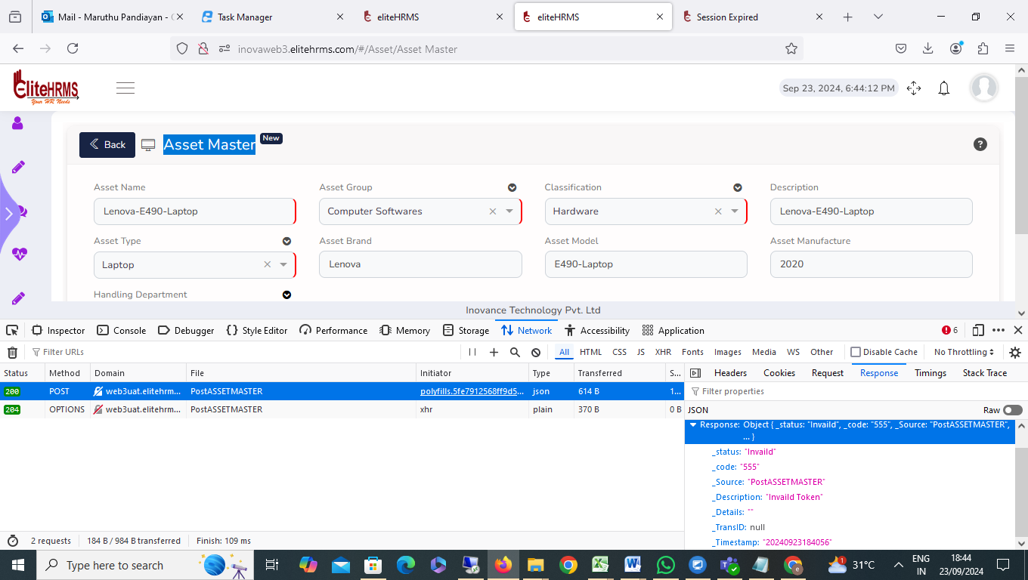

status | "Invaild"
_code | "555"
_Source | "PostASSETMASTER"
_Description | "Invaild Token"
_Details | ""
_TransID | null
_Timestamp | "20240923184056"

- Asset> Vendor Information:
When the vendor information details data entry button was finally clicked, an error message appeared. Please check.
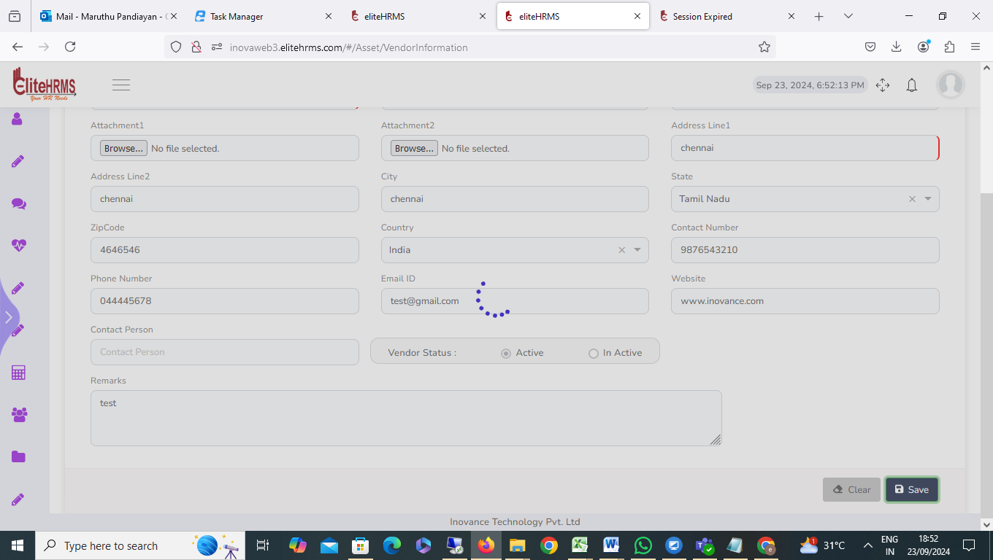

- Asset> Item Master:
I have entered all the details on the Item Master screen, and everything has been filled in correctly. However, the Asset Unit name is not showing. I have checked the HR codes and static code details, but the name is still not visible. Please check
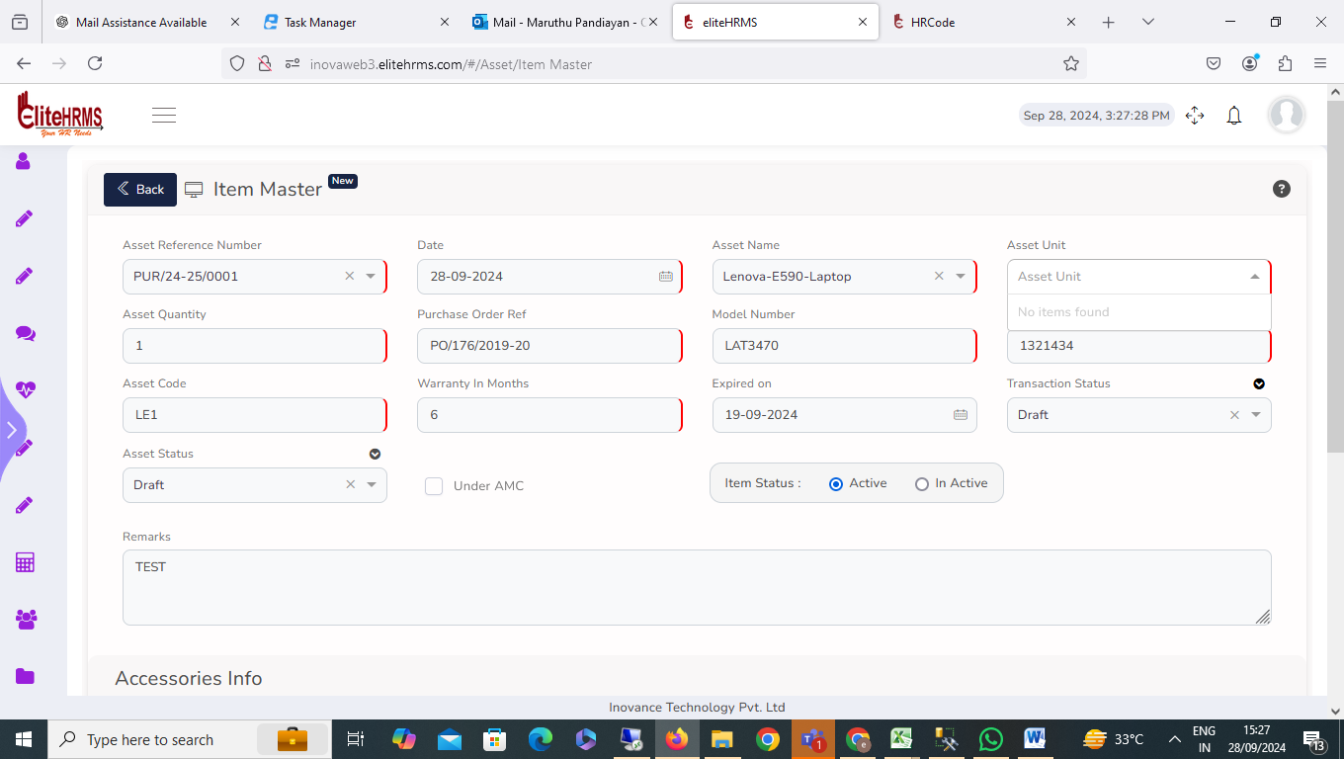

- 4. Asset> Purchase Information:
Purchase Information screen working fine, no issue.

- Asset>AMC Renewal:

AMC Renewal screen working fine, no issue.

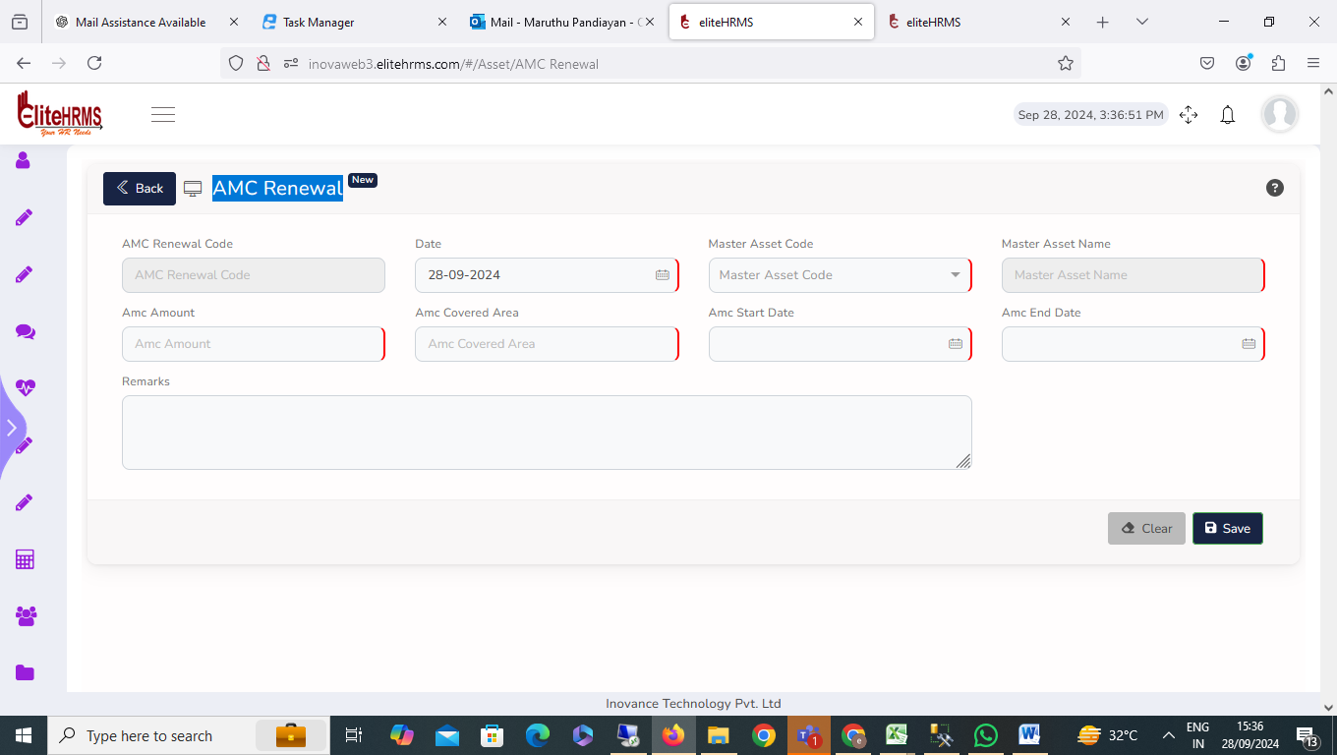

- Asset> New Request:
New Request screen working fine, no issue.

- Asset > Asset Issue> Asset Item Information:

Asset Item Information screen working fine, no issue.
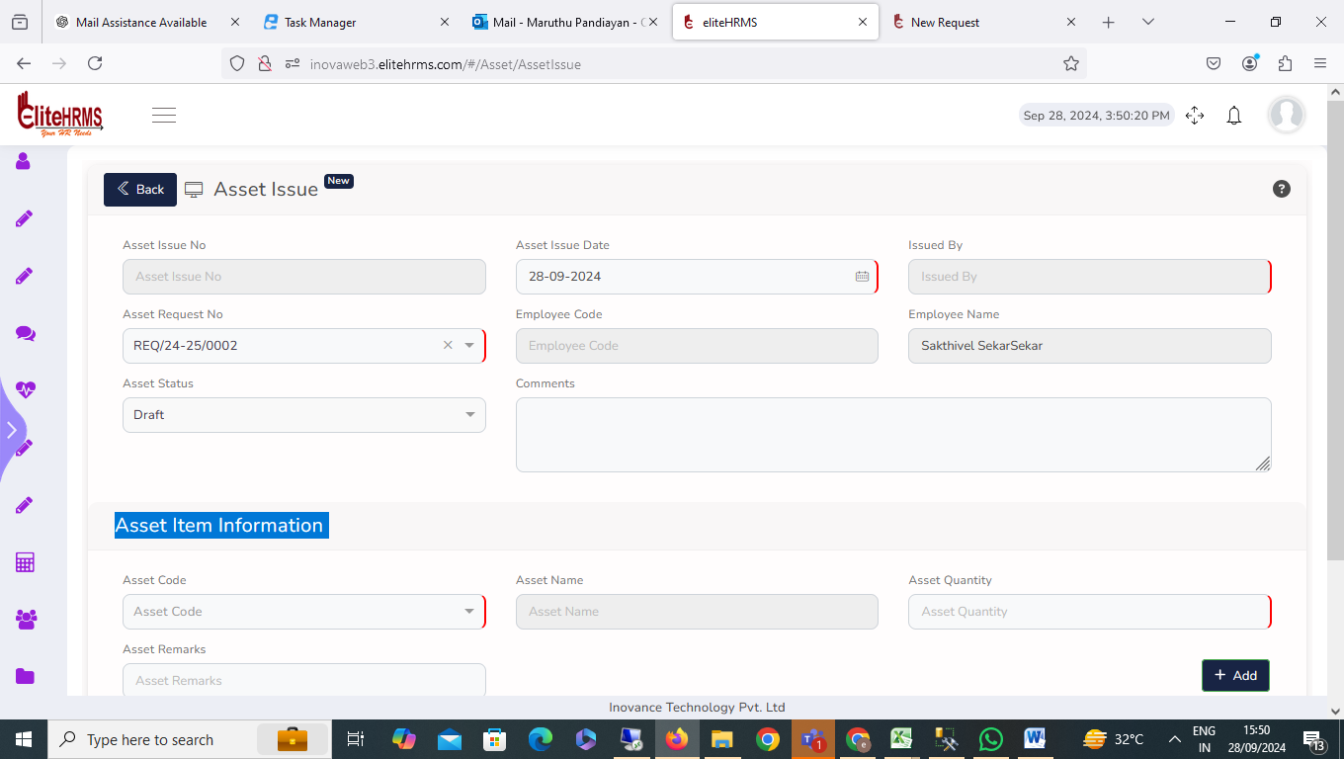

- Asset>Service Request:
I noticed that the Service Request details are not visible.
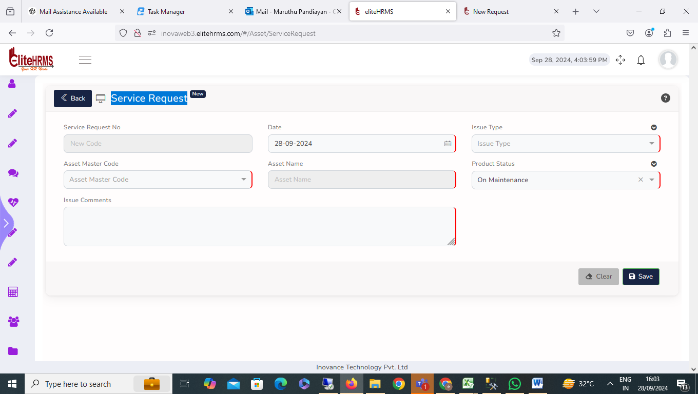

- Action Taken>
Action Taken screen working fine, no issue.

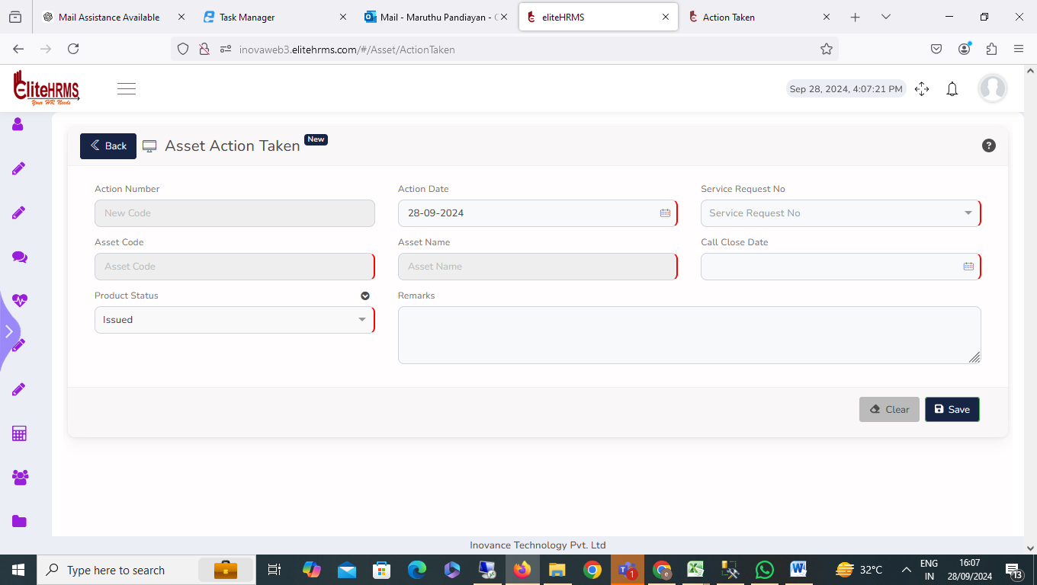

- Asset Receipt:
I have recorded the asset receipt record successfully meassge.but record, not add.
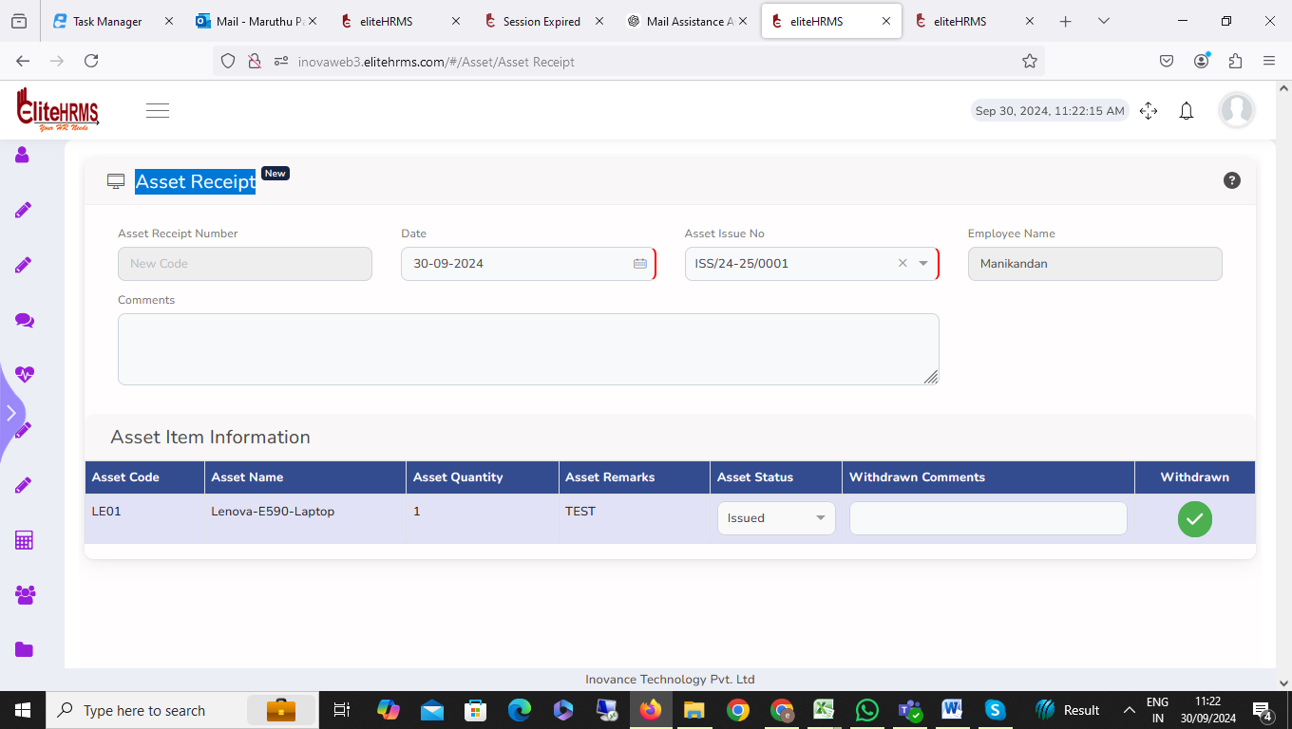

- Asset>Find Asset Item:

I noticed that the Find Asset Item details are not visible
- Review Asset Master:
The Review Asset Master Report screen is working fine. But the problem is that department details are neither visible nor please check.
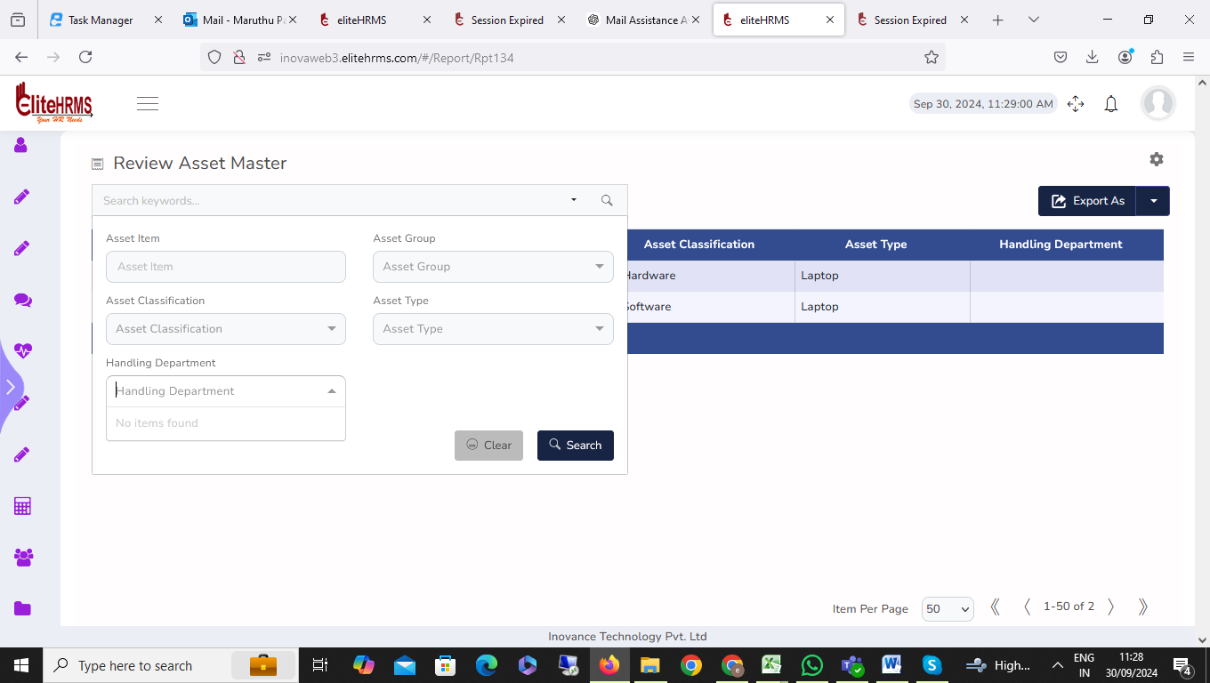

- Review Action Taken:
The Review Action Taken Report screen is not working. And filter options not working
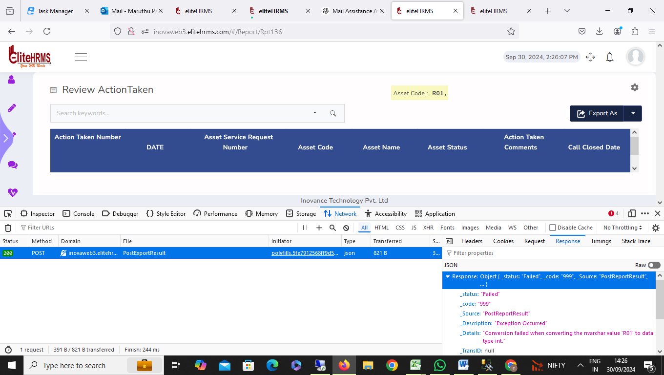

- Review AMC Renewal:
Review AMC Renewal screen working fine, no issue.

- Review Purchase Information:
The Review Purchase Information Report screen is working. And filter options not working
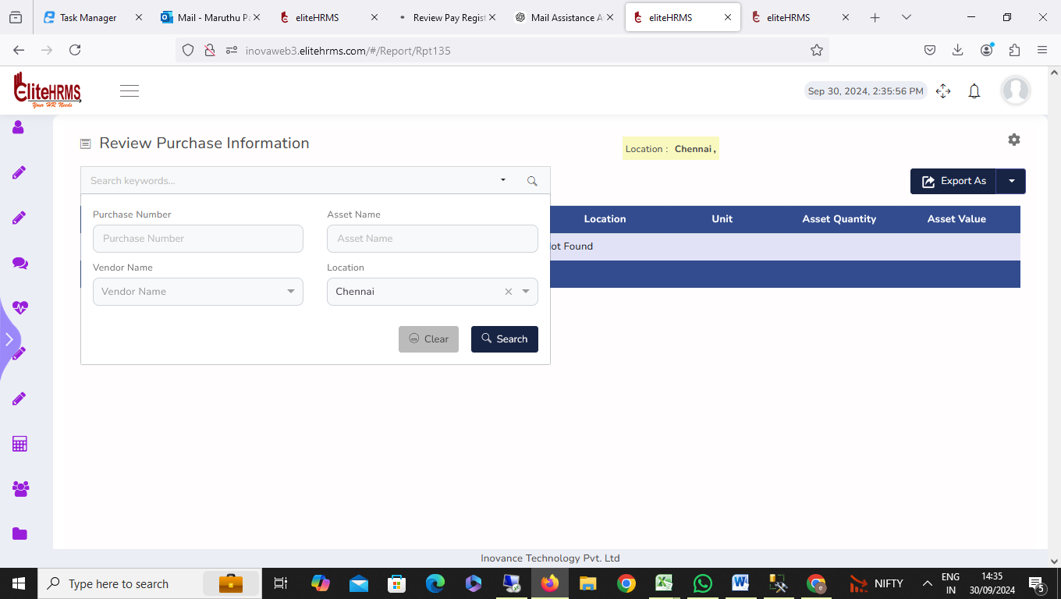

- Review Vendor Info:
Filter options not working.
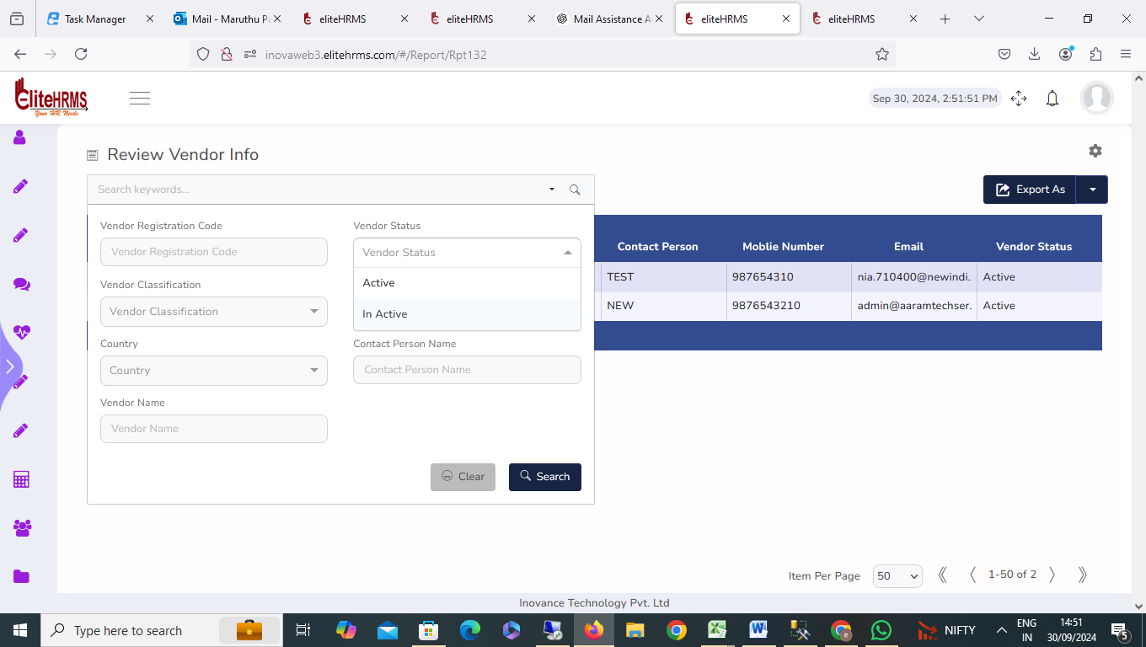
- Review Asset Item Master:
Filter options not working.
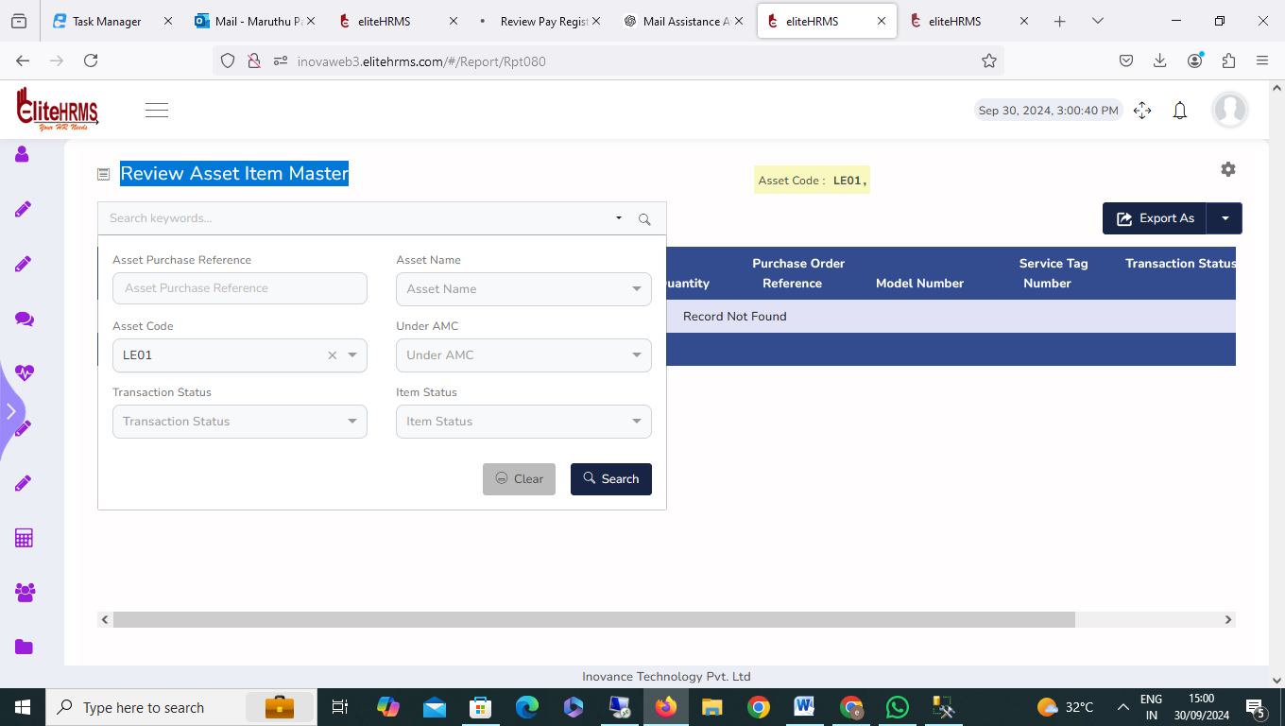

- Review Asset Item Master:
The Review Asset Item Master Report screen is not working. And filter options not working
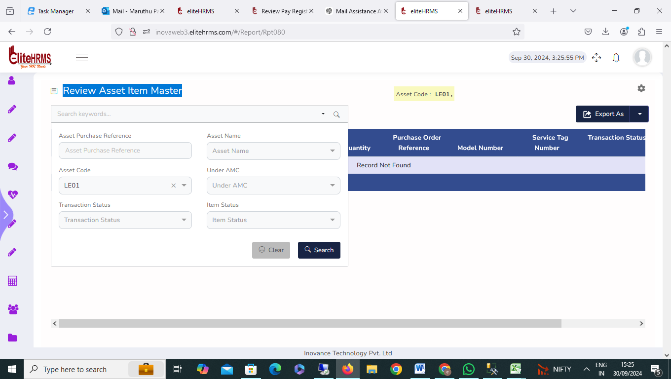

19. Review Asset Item Service:
The Review Asset Item Service Report screen is not working. And filter options not working
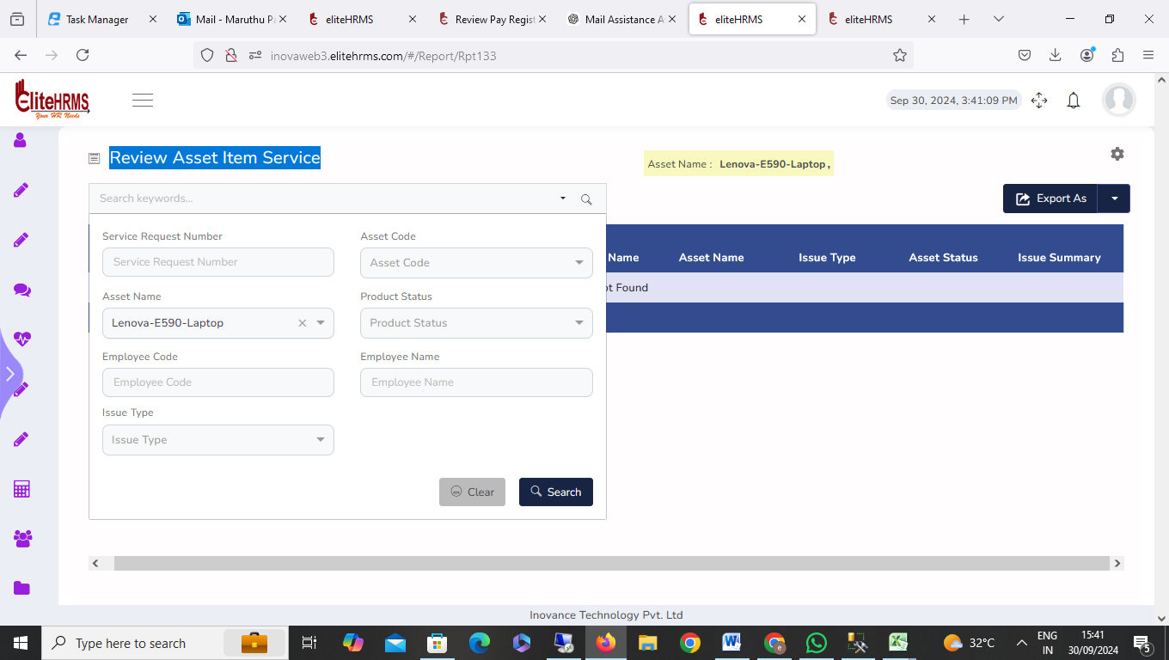

- Review Action Taken:

The Review Action Taken Report screen is not working. And filter options not working

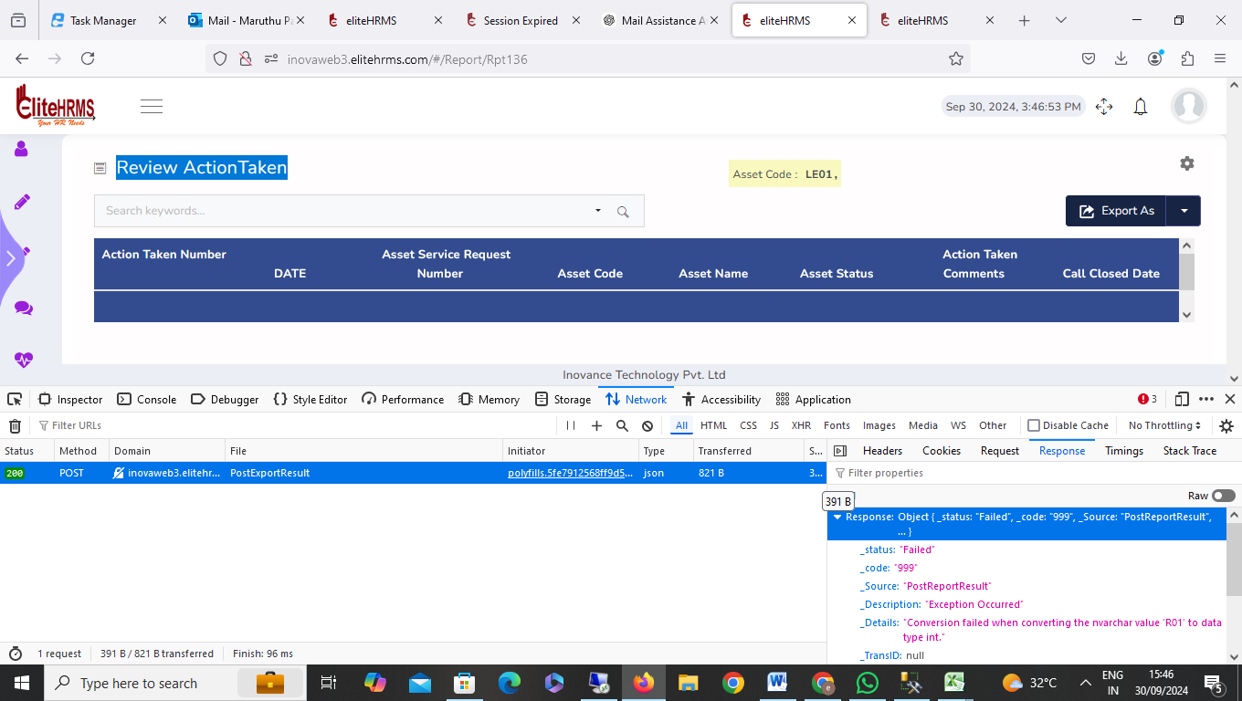

- Review Asset Item Accessories:
Review Asset Item Accessories Report screen is not working. And filter options not working
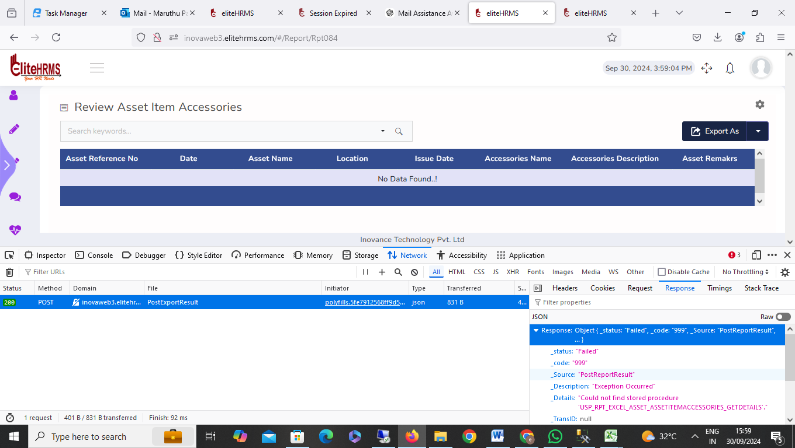

- Review New Request:
Filter options not working

